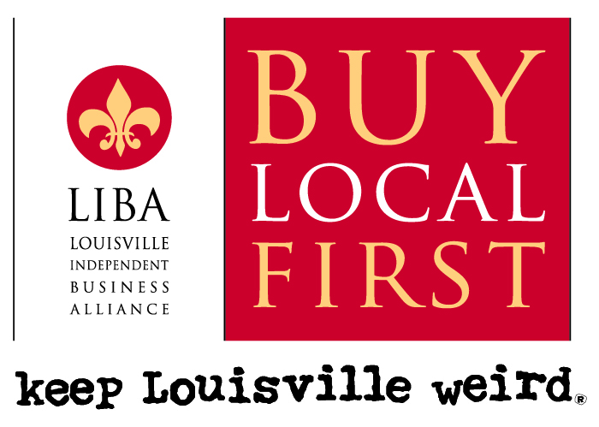
For more information contact:
Jennifer Montgomery, (502) 418-6819
Ali Hawthorne, (502) 262-8580
Jennifer Rubenstein, (502) 500-4669

LIBA Launches Shift Your Shopping Contest on Small Business Saturday,
Asks Shoppers to Celebrate the #holLOUdays

Louisville, KY – The Louisville Independent Business Alliance (LIBA), an alliance of almost 700 locally owned and independent businesses, is wishing the citizens of Louisville happy #holLOUdays in a number of ways this holiday season. Making the shift to local independents is one of the fastest ways to build a strong local economy and create jobs in our community.

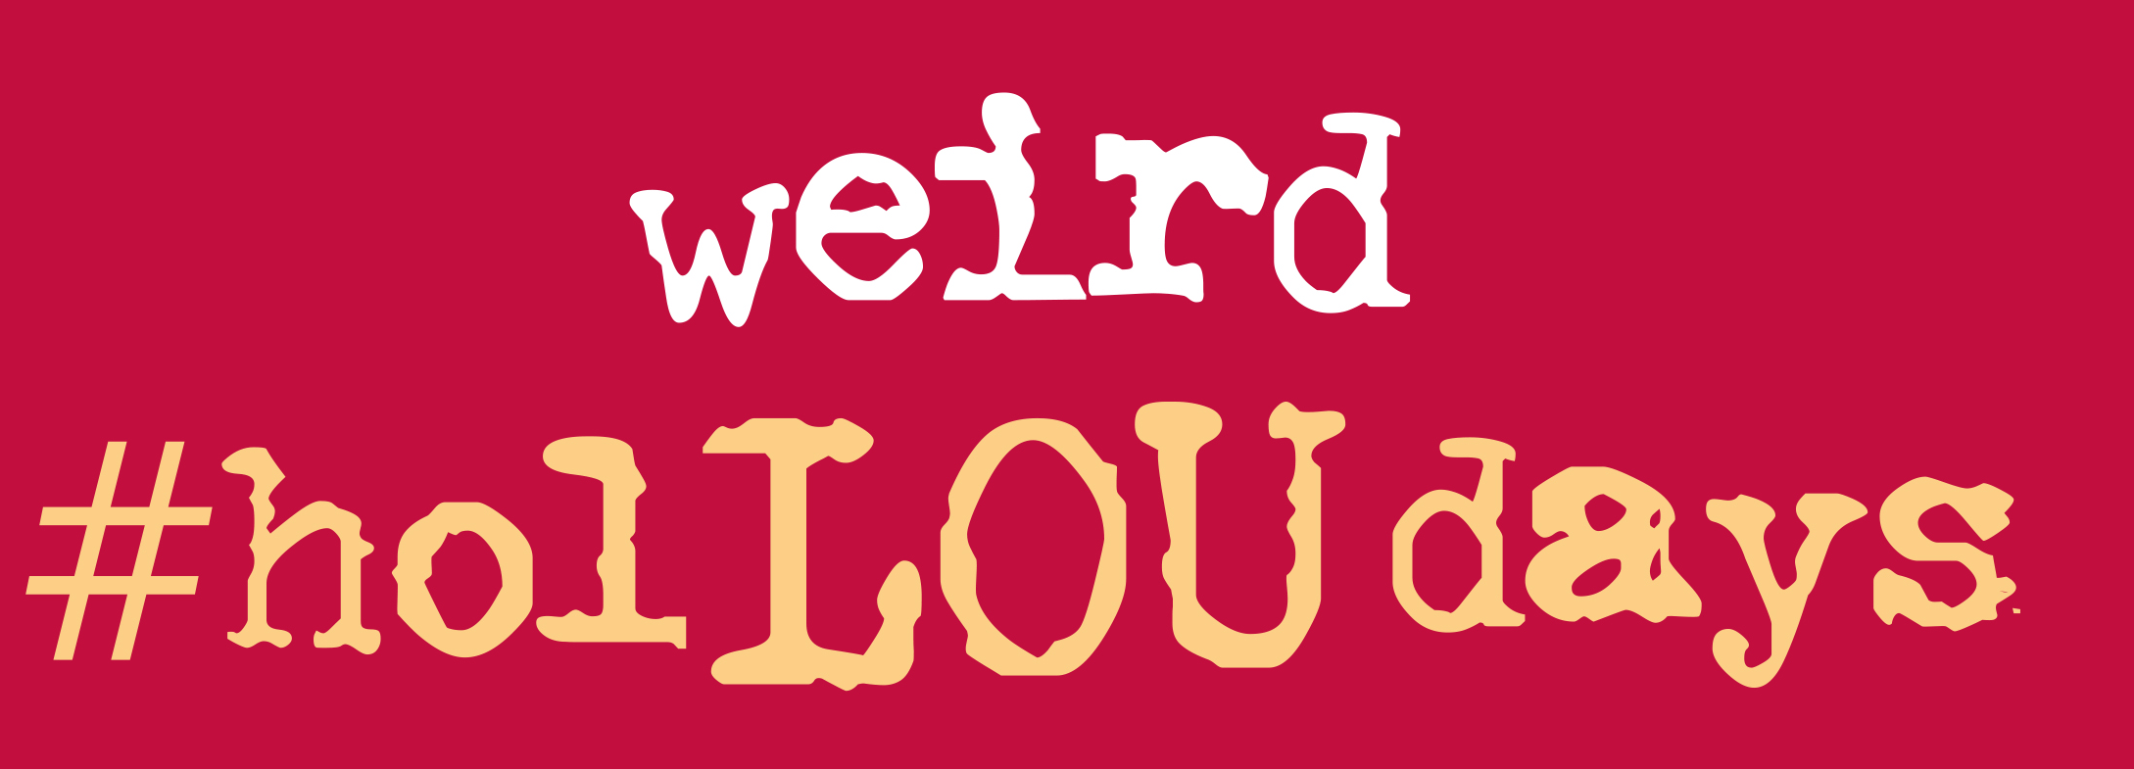
For two lucky people, shopping from independent retailers this holiday season will yield more than just that warm and fuzzy feeling of supporting the local economy. There are two ways to win: 1) collect receipts from five member businesses by 1/5/15, mail in or present the receipts for review at one of the sponsor sites (Revelry Boutique Gallery or Feeders Supply), and you’ll be entered into the drawing to win $1000 in gift certificates to LIBA businesses. Or 2) NEW THIS YEAR: you can simply tag #holLOUdays in your social media posts to be entered to win $250 in gift certificates to LIBA businesses. The winners will be drawn live on Monday, January 12, 2015 on WAVE-3 Listens at 12:30pm, and they will get to choose from close to 700 LIBA businesses where they wish to spend their prize.

A recent study of Louisville-area businesses shows that for every $100 spent at a locally-owned, independent business, $55 is reinvested locally, whereas only $14 is reinvested when that same money is spent at a national chain. By shopping local, consumers also help to preserve the unique community character of the Metro Louisville area.

LIBA members will attend a launch event at Revelry Boutique Gallery, 742 E. Market St. at 5:30pm on Thursday, Nov. 20th.

A press conference will be held on Small Business Saturday, Nov. 29th at 10am at Feeders Supply, 315 Baxter Avenue. Mayor Greg Fischer and Congressman John Yarmuth will be in attendance to make remarks and help our sponsors give away swag (Shop Small shopping bags, holLOUday buttons and balloons). LIBA members throughout the city will be chalking their sidewalks with messages of the “Buy Local” campaign as well.

“The Small Business Saturday campaign and the Shift Your Shopping Contest are aimed at contrasting the typical Black Friday shopping frenzy with a neighborly, community-minded approach to thoughtful gift giving,” said Jennifer Rubenstein, director of LIBA. “Buying from locally-owned independents is a gift to the community because of the financial ramifications and the well-being of the businesses that make our town unique.”

LIBA’s Shift Your Shopping Contest is generously sponsored by Feeders Supply , Revelry Gallery Boutique, Louisville Magazine and LEO Weekly.

Full contest details and a list of participating businesses are at www.keeplouisvilleweird.com.

About the Louisville Independent Business Alliance
The mission of LIBA is to preserve the unique community character of the Metro Louisville area by promoting locally-owned businesses and to educate citizens on the value of buying locally. For more information and a member list, visit www.keeplouisvilleweird.com.

About Small Business Saturday
November 29th marks the fifth annual Small Business Saturday, a day to support the local businesses that create jobs, boost the economy and preserve neighborhoods around the country. Small Business Saturday was created in 2010 in response to small business owners’ most pressing need: more customers.

- END -

American Independent Business Alliance - The Multiplier Effect of Local Independent Business Ownership - http://www.amiba.net/resources/multiplier-effect

